Ravan Muradzada
- An IP address in your Linux machine is the network identity of that machine.
The command is `ip a`. The result is:

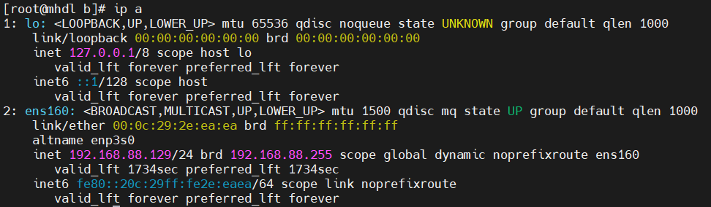
From here, we take `192.168.88.129` as ip.

- We wrote `ssh username@ip_address`. In our example, we need to write:
`ssh root@192.168.88.129`.

- The command will be like that:
`netstat -tuln | grep LISTEN`
In our virtual machines, there is no netstat command downloaded, so I cannot show its output here. In this command, the first part gets open ports, grep find lines with `LISTEN` from the list.

- First, I need to see the open ports in linux machine. To see it, we need to type this command: `ss -tuln | cat`. There are both udp and tcp ports, however with telnet we cannot reach udp ports. From this command, I found one open port (with tcp), it is 22.
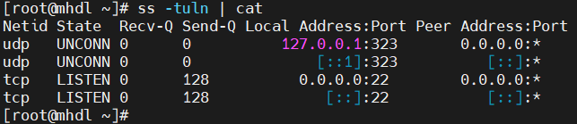
We also need to have ip address of linux machine. So we write `ip a` command again and take ip. (We learned it detailed in Question 1).
To try to connect from windows machine, I opened cmd and type
`telnet <IP> <PORT>`:
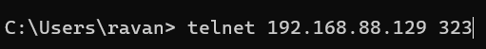

It is successful and the result:
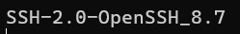

- To check which directory I am, we need to type `pwd` command which means `print working directory`. It locates in `/bin` folder.
- I tried, but because of subscription problems, I failed to install it.
- We need to use `mkdir -p`:
- It tries to remove `/` (whole system) without asking, because we use `-f` which is forcing to delete everything in the system. However, in modern systems that command directly does not work, we need to add another option like `--no-preserve-root` to really delete whole system.
- 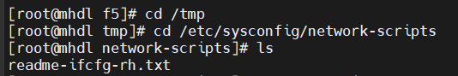
- `cd -` travels between the last two directories we are. 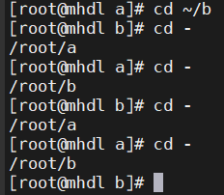 Here initially we were in `a` and then went `b` directory. Now these are the last two directories we travelled. So when we run `cd -`, it will go `a` and `b` sequentially.
`cd ..` basically goes the parent directory. 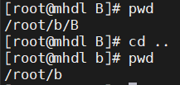
- `cd ~` goes to home directory of the current user. `cd .` just stays the same directory, because `.` means the current directory. To check which directory I am, I write `pwd`
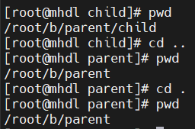

- `rm` itself removes files from the system. If we want to remove directories, we need to use `-r` which means `recursive`. When we try to remove files or directories from the system it asks whether we are sure to remove it or not. If we really to continue and remove, we press `y` to remove. Usage of `-f` option with `rm` prevents this question, so the command removes it without asking.
- 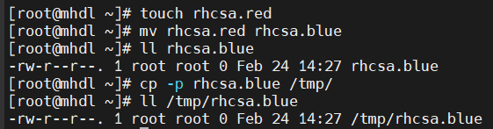
The option we need to use is `-p` which means `preserve`.

- `df` command shows us how much disk space is used and free on our system. We can use `-h` option to make the result more human-readable.
`du` command checks the size of the directory or file, not the whole disk. If we use it like `du -sh`, it shows the size of the current directory. However, if we use it like `du -sh *`, then it shows the size of each file in the current directory.
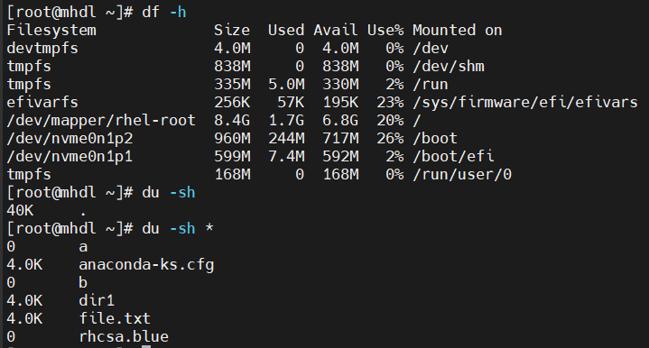

- a. Red Hat 9.7; b. ` #1 SMP PREEMPT_DYNAMIC Fri Oct 17 14:16:35 EDT 2025 ` ; c. We can use `uname -v` to see kernel version, also we can use `uname -a` to see more information about the system.

- We can use whether `exit` or `logout` command. It is possible to press `Ctrl+D` too.

It first finds the file itself from the system, then sends the output to `head` with exec feature of `find` command, then output is sent to `tail` as input.
If we already know where the file is located, we can just write like that:

- 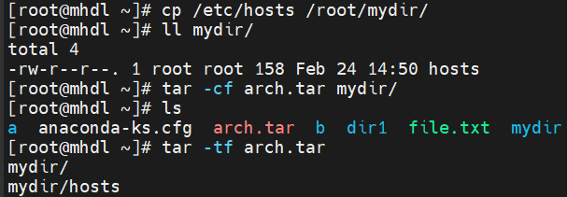

- When I run history command, it shows my command history. When I run `!20`, it will run 20th command in history.
- `!!` runs the last command again.
- It looks at my history, filters and shows all usages of `grep` in history:
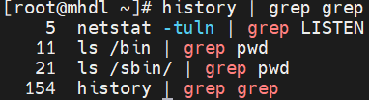

- 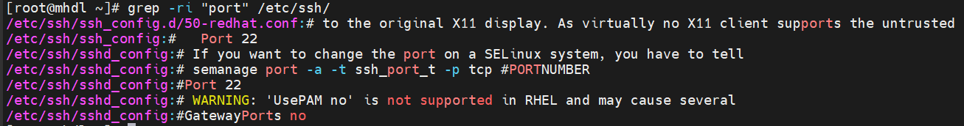
- `-A n` shows n lines after the match. `-B` shows n lines before the match. `-C` shows n lines before and after the match. `-o` only print the matching part. `-w` match whole words only.

- 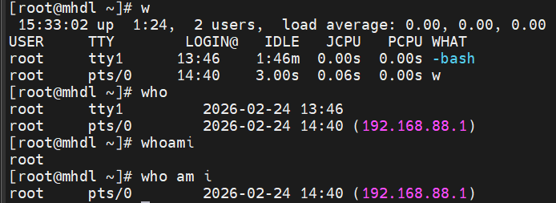
- 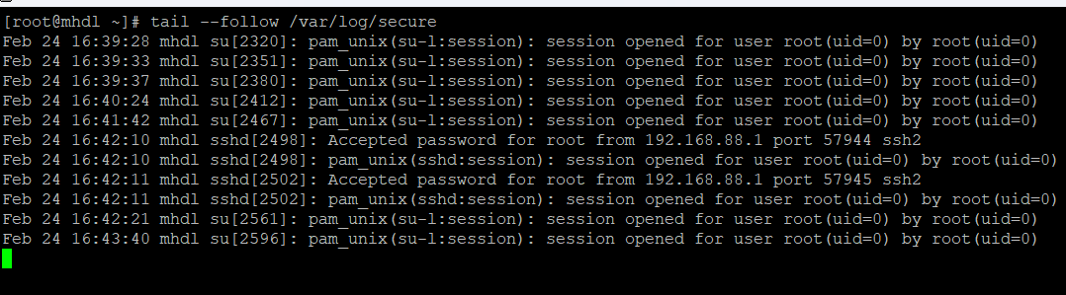
When I use `--follow` option I can track the changes live.

- It tries to install everything starting with `bash`.

- `history` basically shows the command history. `man` is the command to get detailed information about any command, we type it like that `man pwd`. `--help` is also very useful to learn detailed about commands, however it has less details than `man` command.

- To see all files including hidden ones, we need to type `ls -a` where `-a` means all files.
- To create a hidden file, we need to name file starting `.`, like `.my_hidden_file.txt`.
`ls` itself cannot show hidden files, but `ls -a` can.

- `>` redirects and overwrites, so it removes the content and then adds new content. So, after the redirection in bio.txt, there will be "Linux was created by Linus Torvalds".
`>>` redirects and appends without overwriting. So, after the redirections in session.txt, there will be
“IDTECH RHCSA Session”
“IDTECH RHCE and DevOPS Session”

- `a=5` and `color=blue` created variables and assign value to them. `echo $a` and `echo $color` prints the values of the variables. However, `echo a` or `echo color` prints just the strings of `a` and `color`.

